ML Code with Feature Selection – Explanation

1.Data Preprocessing before Feature selection
1.1 Removing Null values.
As we don’t have any null values in the dataset Moving to next.

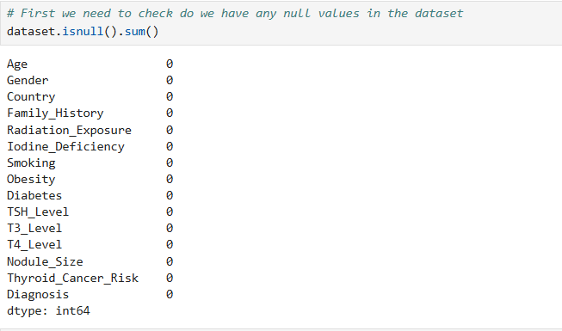

  - Minimizing dataset for research
As the raw dataset has 2,12,691 rows , the calculations take too much time . So here we are minimizing the dataset to 30% from its original by selecting random rows.
Once we are done with feature selection we can train the model by entire dataset.

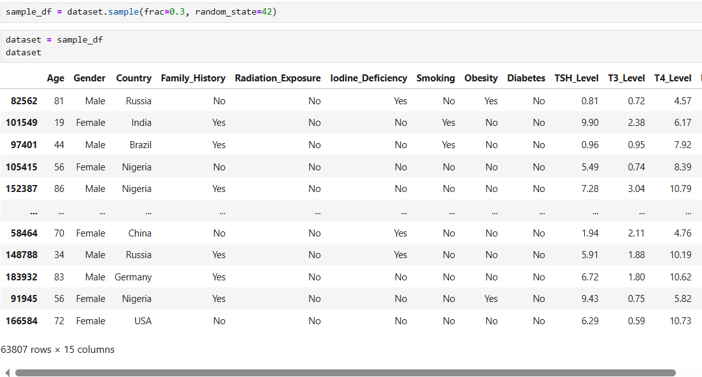
Rows minimized to 63,807.
  - Encoding categorical columns to Numerical columns

- Label encoding
Needed as Thyroid_Cancer_Risk column has Low, Medium, High values.
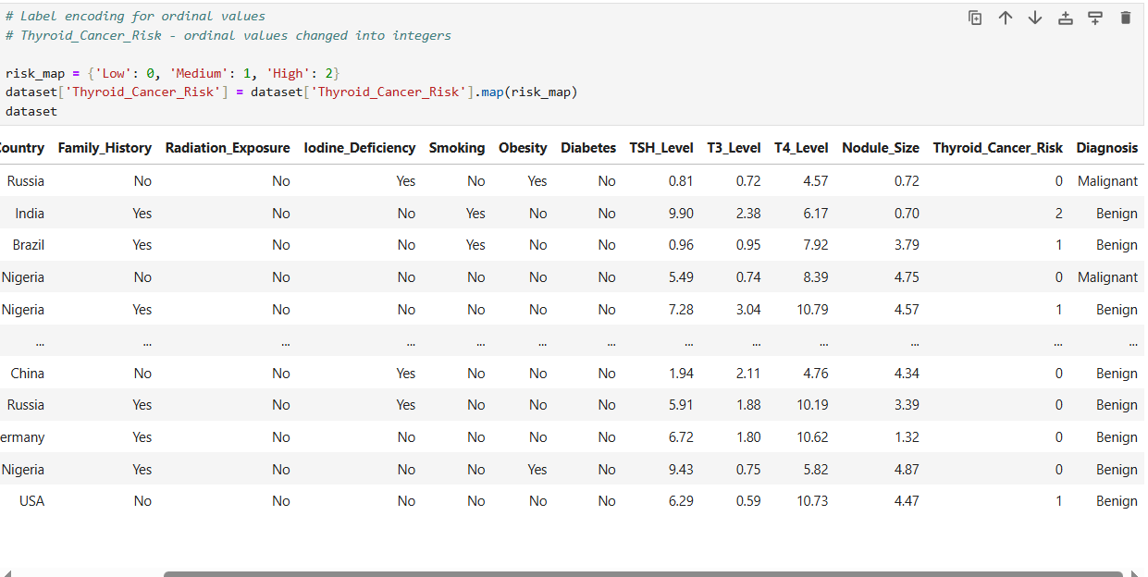

- One-Hot Encoding:
This will change the categorical values to binary values in the dataset.
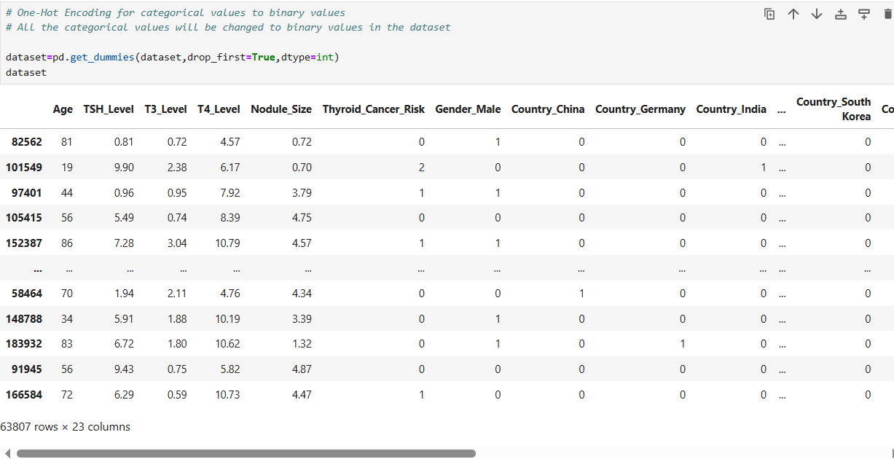

  - Saving the Preprocessed data to separate csv file.

Feature Selection

Trying with SelectKBest
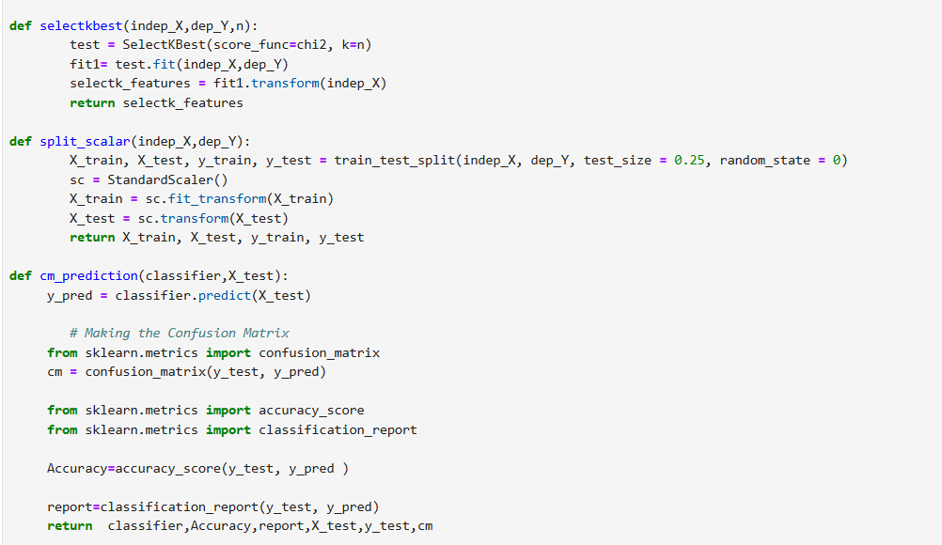

2.1.Created function for SelectKBest
- SelectKBest(score_func=chi2, k=n) will pick the top n features using the Chi-Square test.
- fit1.fit(indep_X,dep_Y) will learn which features are important.
- fit1.transform(indep_X) will keep only the best n features then return it.

2.2. Created a function for Split Scalar
- train_test_split(...) will Split the data into training (75%) and testing (25%).
- StandardScaler() - scales features so they are on the same range.
- fit_transform on training data - learn scaling values (mean, std) and apply.
- transform on test data - apply the same scaling.
2.3. Created a function for Prediction using confusion matrix
- Predict(X_test) - The model predict using test data.
- Confusion_matrix (y_test, y_pred) will create the confusion matrix
- Accuracy – Correct predictions saved in accuracy
- Classification_report – detailed report created for the predictions.

2.4. Created separate functions for below Algorithms
- Logistic Regression, Support Vector Machine (SVM) Linear Algorithm, SVM Non-Linear Algorithm, Naive Bayes, K-Nearest Neighbors, Decision Tree and Random Forest.
- It will create the instance of classifier and Trains the model with training data
- Then it will call prediction function and make prediction using test data and returns accuracy, report and confusion matrix.
2.5. Created a function for SelectK
  - It accepts inputs that hold accuracy values for different classifiers
  - pd.DataFrame(index=['ChiSquare'], columns=['Logistic…] - Creates an empty dataframe with one row index - 'ChiSquare' & several col
  - enumerate(dataframe.index): - is ['ChiSquare'] --- so this loop runs once

  - enumerate(...) gives two values each iteration:
    - number → the integer position (0 for the first row)
    - index → the actual index label (the string 'ChiSquare')
  - dataframe['Logistic'][index] = acclog[number] - Sets the cell at row 'ChiSquare' and column 'Logistic' to the value acclog[0].
  - Acclog[0] – accuracy value for logistic is set to chiSquare row and logistic col of the dataframe.
  - Like above all the accuracy values will be placed to specific columns.

2.6Assigning Input and Output Values
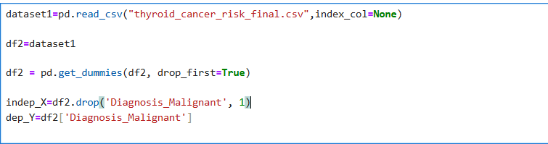
Input – All rows in df2 except Diagnosis_Malignant
Output – Diagnosis_Malignant
2.7.Calling a function selectkbest
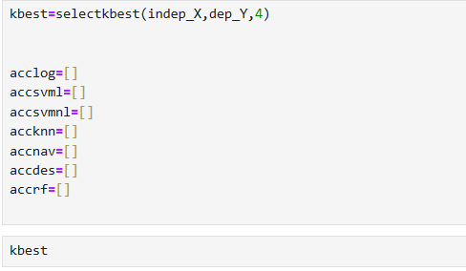
- Parameters are input ,output and n value (4 most important features)
- Empty Python lists created to store accuracy values for different classifiers

2.8.Training and Evaluation
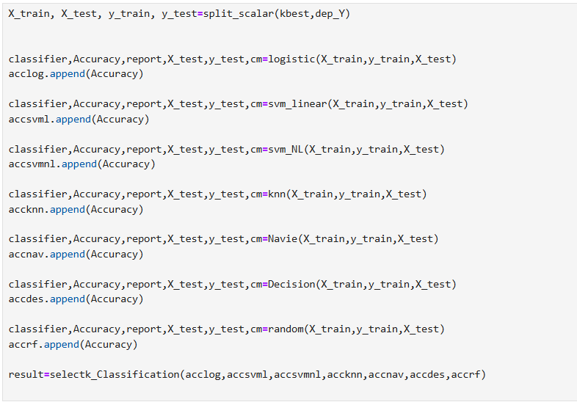
- X_train, X_test, y_train, y_test = split_scalar(kbest, dep_Y) – split the dataset to training and test – kbest(input var selected features)
- classifier, Accuracy, report, X_test, y_test, cm = logistic(X_train, y_train, X_test)
- acclog.append(Accuracy)
  - Trains a Logistic Regression model.
  - Returns:
  - classifier → trained model
  - Accuracy → test accuracy
  - report → classification report
  - cm → confusion matrix

- Appends the accuracy to the list acclog.
- Like above all the model will be trained and tested and the accuracy value is appended to the list.
- result = selectk_Classification(acclog, accsvml, accsvmnl, accknn, accnav, accdes, accrf) – will create the dataframe using the accuracy values .

2.9.Analyzing Results

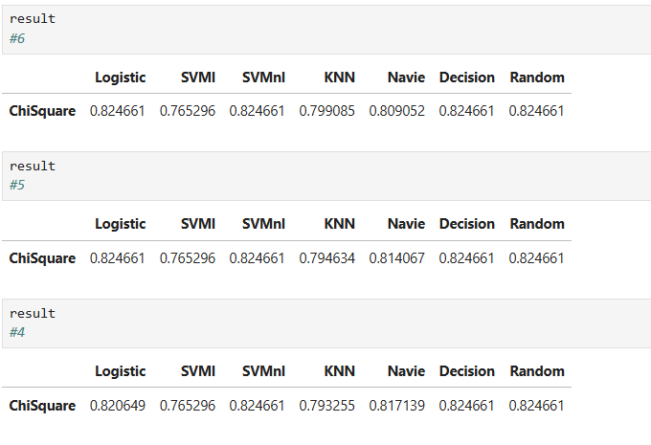
Summary :

- Model accuracy remains consistent (~0.82) as the number of selected features increases from 4 to 6.
- Logistic Regression, Decision Tree, and Random Forest show the best and most stable performance across all feature sets.
- KNN and Naive Bayes exhibit slightly lower accuracy.

Feature Importance (Tree based models)
As we have the accuracy 82% from selectKBest, we are trying with one more feature selection method to check whether we can achieve more accuracy.
- Creating the function for Feature Importance

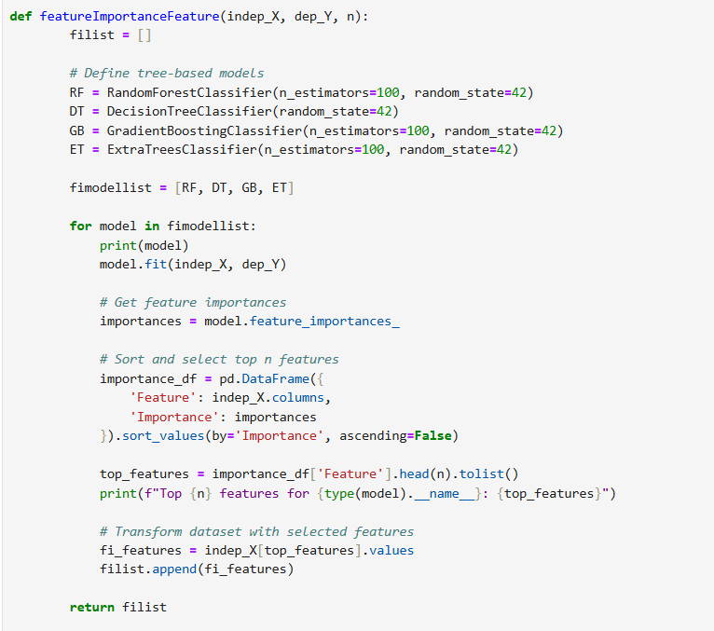

- Created empty list – filist[]
- Defined the tree based models
- fimodellist = [RF, DT, GB, ET] - Stores all the models in a list
- In For loop – loops through each model in the list print its name.
- model.fit(indep_X, dep_Y) - Train the model on full dataset
- importances = model.feature_importances_ - built-in property which will give numerical score for every feature
- Created a DataFrame showing each feature and its importance score.
- Sorts the features in descending order, so the most important features come first.
- top_features = importance_df['Feature'].head(n).tolist() - Selecting the top n features based on their importance scores and storing it to a list
- fi_features = indep_X[top_features].values – we are storing the dataset containing only its most important features.-- .values get the values of those features .
- Appending it to the list

- Created other functions – split scalar, cm_predictions and all other algorithms.

- Created function for summarising accuracy results
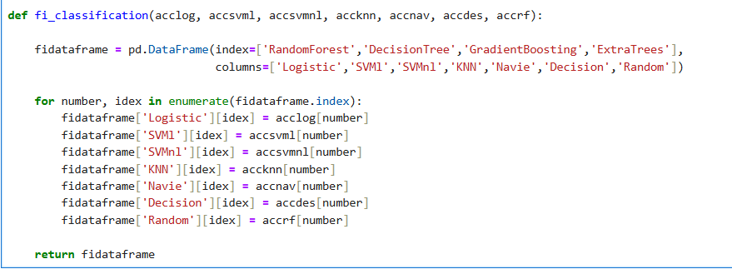
- This function collects accuracy scores from different classifiers when using feature importance-based feature selection.
- Creates an empty Pandas DataFrame with:
- Rows =RandomForest, DecisionTree, GradientBoosting, ExtraTrees
- Columns = Logistic, SVMl, SVMnl, KNN, Navie, Decision, Random
- This DataFrame will store accuracy values for each combination.
- For loop – here iteration occurs for each tree based model(row)
- Dataframe will be populated with all the accuracy values at the end.

- Assigning Input and Output Values

Input – All rows in df2 except Diagnosis_Malignant
Output – Diagnosis_Malignant

- Calling featureImportanceFeature function

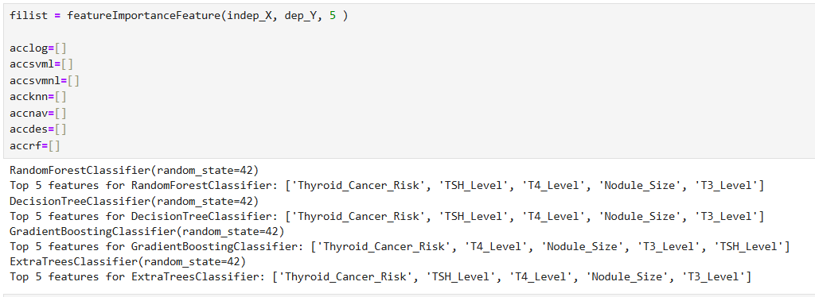

- Parameters are input ,output and n value (selects the top n features to be selected)
- Empty Python lists created to store accuracy values for different classifiers
- Output of the code shown above - five features which are selected displayed

- Model Evaluation
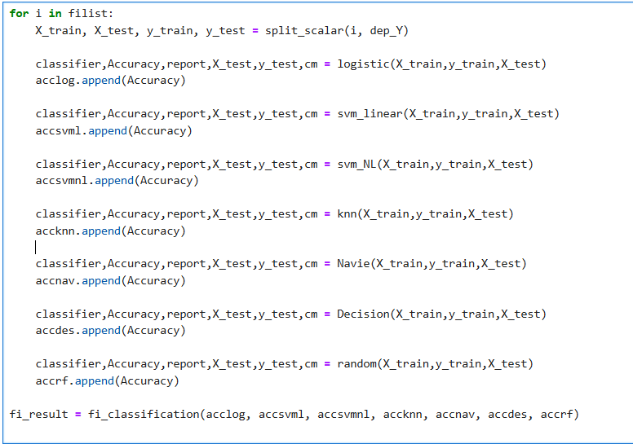
- For each dataset in filist (which contains top features chosen by different tree-based models), split it into training and testing sets.
- Train multiple classifiers and measure accuracy
- Save each classifier’s accuracy in separate lists
- Use fi_classification() to combine all accuracies into a DataFrame

- Results
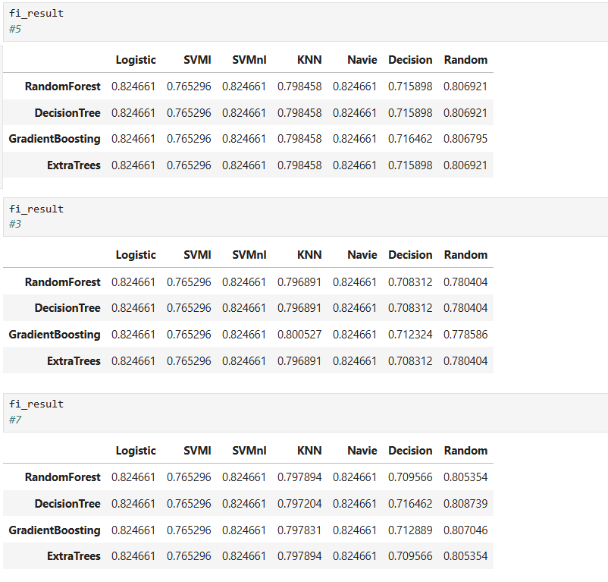
Summary:
- Model performance remains steady (~0.82 accuracy) across all tree-based feature selection techniques (Random Forest, Decision Tree, Gradient Boosting, Extra Trees).
- Logistic Regression , Navie and SVM models maintain consistent and strong performance regardless of the number of selected features.
- Decision Tree shows slightly lower accuracy compared to other models.

Conclusion:
“Both SelectKBest (Chi-Square) and Model-Based Feature Importance methods resulted in comparable model accuracies (~82%).
This indicates that the important predictive features are consistent across methods.
Ensemble-based models like Random Forest and Gradient Boosting provided slightly better stability and accuracy, making them suitable for final model selection.”
Choosing Random Forest.
After feature selection, the top 5 most significant predictors were identified as:
Thyroid_Cancer_Risk, TSH_Level, T4_Level, Nodule_Size, and T3_Level.

